Olympic Torch
Materials Needed:
- Paper Towel Roll
- Paint
- Tape
- Glue
- Tissue Paper
Instructions:
Paint the paper towel roll if you like. Set it aside to dry. (You can also use two toilet tissue rolls taped together to make one long roll).
You need red, orange, and yellow tissue paper. You will want to cut out this shape from the tissue paper (the actual size should be about 8 inches tall by 12 inches wide):
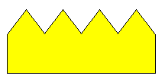
Cut two shapes out of each color of tissue paper. These will be your flames! Lay each piece of tissue paper down on top of each other as shown here:
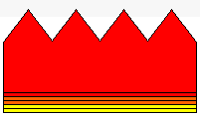
Note: Each piece will overlap just by approxomately 1/4 of an inch!
Tape along the bottom of the tissue paper to help hold it is place for the next step. Be very generous with the tape!
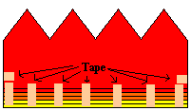
Loosely roll the tissue so it forms a circle with the yellow on the outside and the red on the inside. Gather in together along the bottom, straight edge, tape. It should look similar to this:
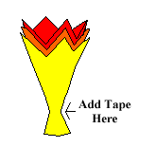
Using a generous amount of glue, stick the tape end of your flame into one of the ends of the paper towel roll:

Let the glue dry, fluff up and spread out your flames a little bit, and you have your very own Olympic Torch! http://familycrafts.about.com/library/projects/blolytorch.htm

